**Veterans Day Wall of Honor**

In recognition of Veterans Day, Unami will be creating a “Wall of Honor” to pay tribute to family members of Unami students and staff that served in the military. In recognition of their service to our country, we are asking students to create a digital poster that will be showcased in the front hallway of our building.

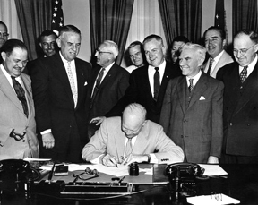**Background:** An Act (52 Stat. 351; 5 U. S. Code, Sec. 87a) approved May 13, 1938, made the 11th of November in each year a legal holiday—a day to be dedicated to the cause of world peace and to be thereafter celebrated and known as "Armistice Day." Armistice Day was primarily a day set aside to honor veterans of World War I, but in 1954, after World War II had required the greatest mobilization of soldiers, sailors, Marines and airmen in the Nation’s history; after American forces had fought aggression in Korea, the 83rd Congress, at the urging of the veterans service organizations, amended the Act of 1938 by striking out the word "Armistice" and inserting in its place the word "Veterans." With the approval of this legislation (Public Law 380) on June 1, 1954, November 11th became a day to honor American veterans of all wars. *Source: United States Department of Veterans Affairs*

**How does it work?**

On the second page of this document is a template that you can fill in using either a digital or scanned picture of your family member **in uniform**. Included in the template is the following information. Please use 12 point font to fill out the information in the template.

**Information needed**

* Your child’s name
* Your child’s social studies teacher
* Person’s name
* Branch of the military
* Years of service
* Conflict involved in (if applicable)
* Rank
* Where they were stationed
* Their relationship to you
* Reflection Piece

**DEADLINE FOR TURNING IN PICTURES AND MEMORABILIA IS OCTOBER 31ST!**

|  |
| --- |
| Insert Picture Here |



Name

Conflict Involved In (if applicable)

Branch of Military:

Years of Service:

Rank:

Where stationed:

Student Name: Social Studies Teacher:

Relationship to Student:

Why is this person important to you and your family?